**Get me the IP address of a particular domain guvi.in**

**Command used:**

**ping** guvi.in

**Screenshot:**

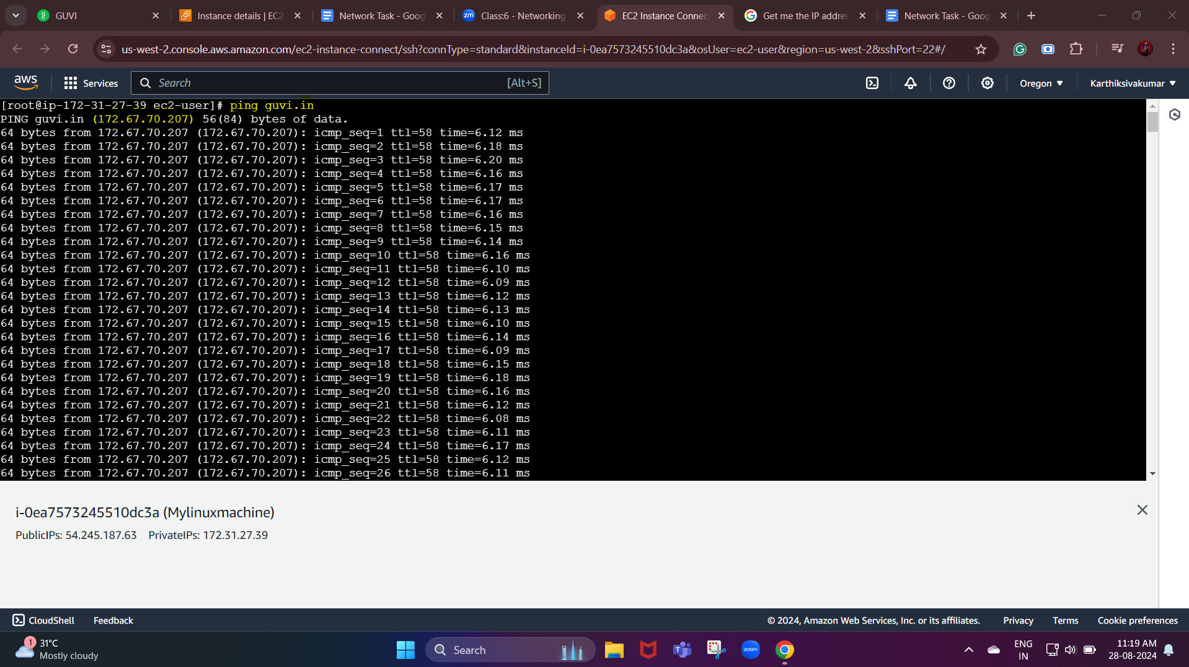

**Finding my CPU/memory usage of my server.**

**Command used:**

**top**

**Screenshot:**

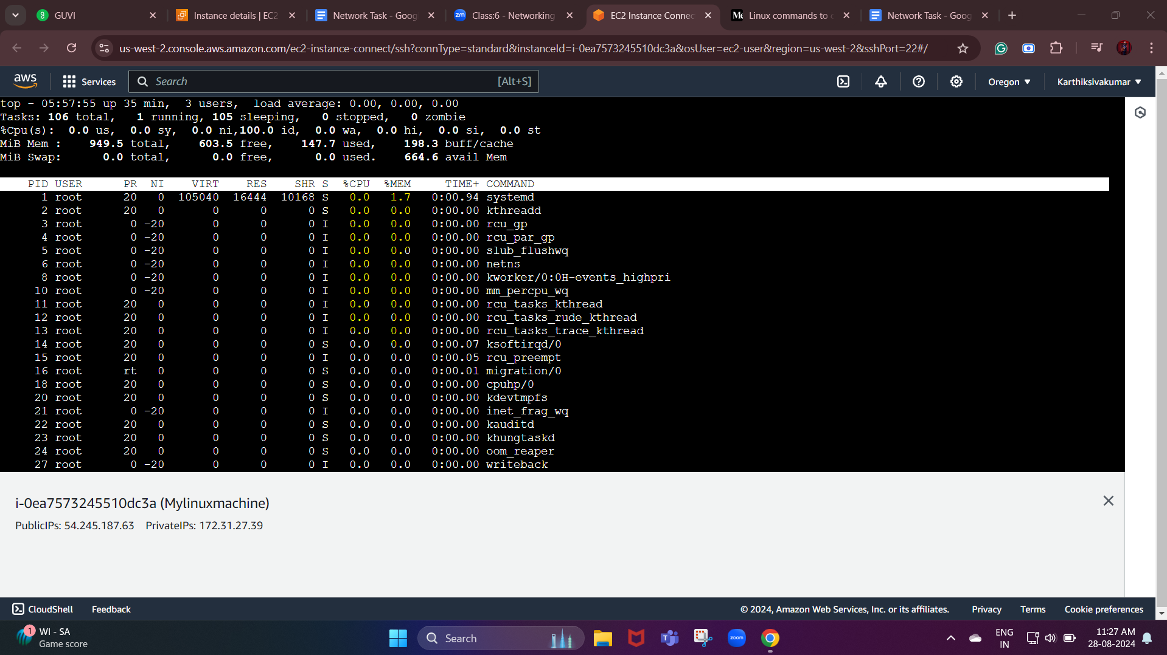

**Test the connectivity between 2 nodes**

Tracing the path between two systems. It will display the different routers or hops needed to travel from the source system to the destination system. Tracert will also show the time it takes to get from the source to the destination.

**Command used:**

**tracert (domain name)**

**Screenshot:**

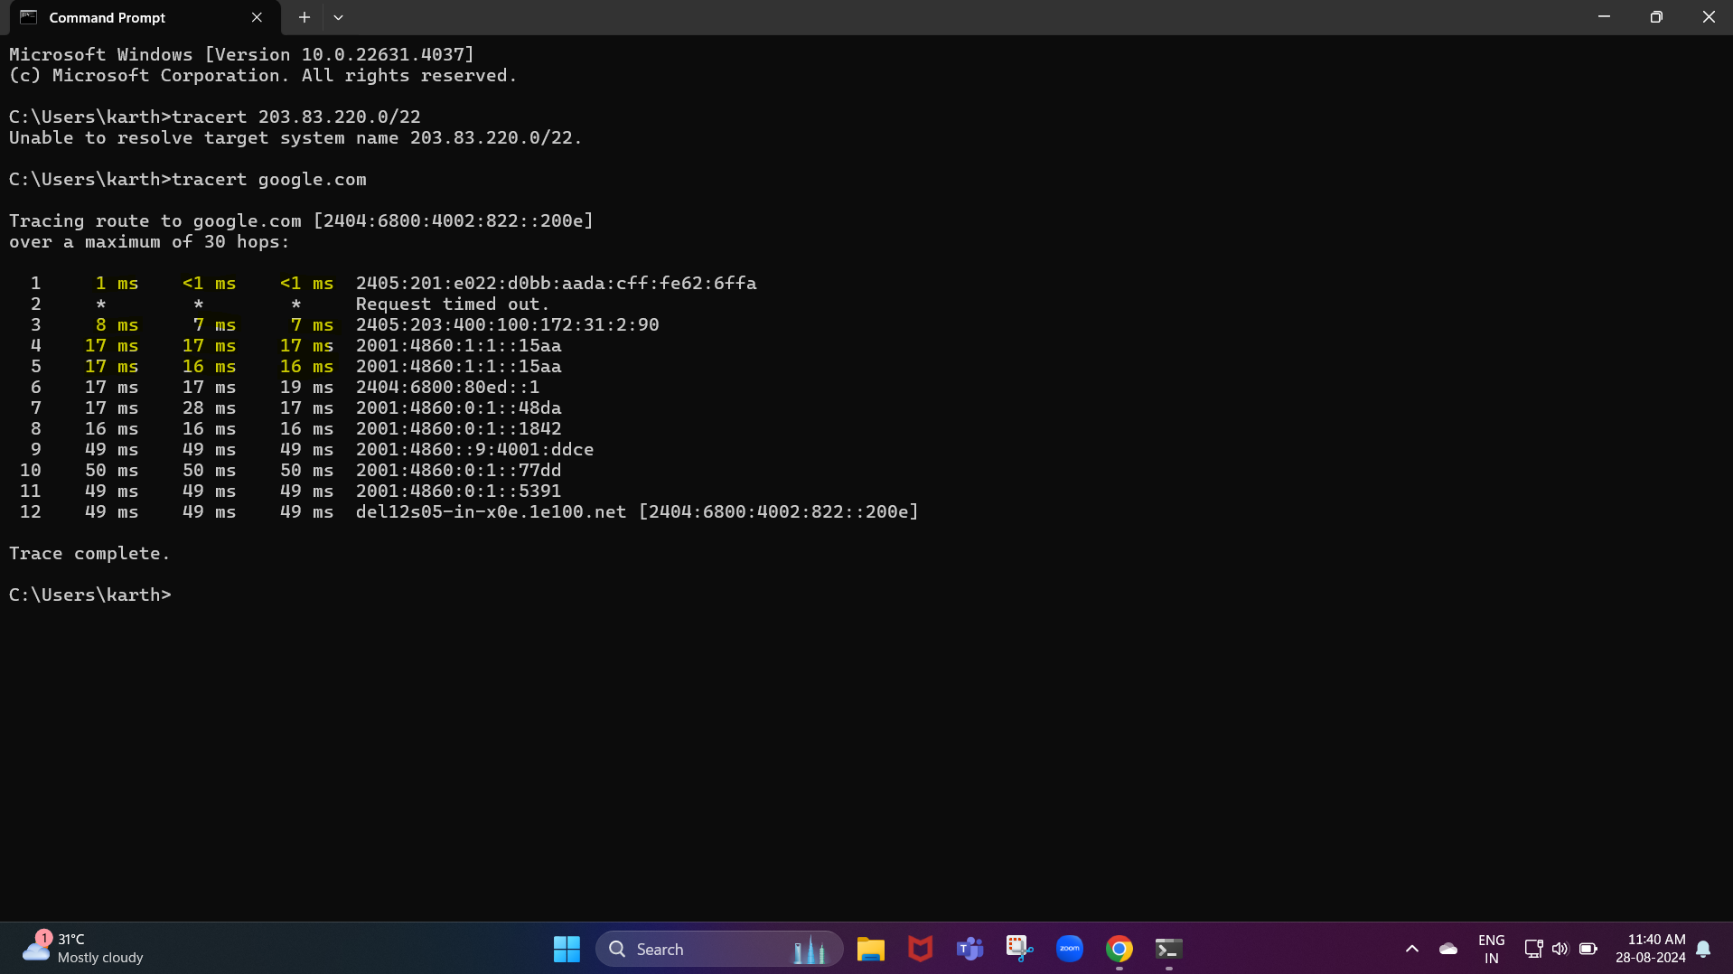

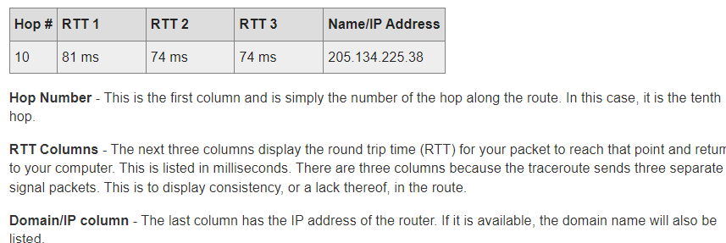

**Check whether my port is open or not**

**Command used :**

**telnet (hostname + port number)**

**If the port is open, we will only see the cursor on the cmd page. If it is not open, we see like could not open a connection to the host.**

**Screenshots:**

